EXPERIMENT – 5

**MCQ:**

1. When an RGB image is displayed, the entire image is black. Then,

a) each pixel in the image have the same, but any nonzero value

b) all the three colour components have different values

c) elements in each colour components have same value

d) all the pixels have the same value of zero.

2. Suppose X, Y and Z are three matrices of size 256x256 and X and Y have the same elements. Assume that all the elements in Z has a value of 255 and Y is a zero matrix. If X,Y and Z corresponds to R,G and B components of an image A displayed,

a) The image A is Black

b) The image A is Blue

c) The image A is Yellow

d) The image A is Red

Answers: Q1 d) all the pixels have the same value of zero Q2 b) the image is blue

Assignment – 1

clc;

clear all;

close all;

RGB = imread('len_top.jpg');

red = RGB(:,:,1);

green = RGB(:,:,2);

blue = RGB(:,:,3);

a = zeros(size(RGB, 1), size(RGB, 2));

just_red = cat(3, red, a, a);

just_green = cat(3, a, green, a);

just_blue = cat(3, a, a, blue);

figure

subplot(221)

imshow(RGB)

subplot(222)

imshow(just_red)

subplot(223)

imshow(just_green)

subplot(224)

imshow(just_blue)

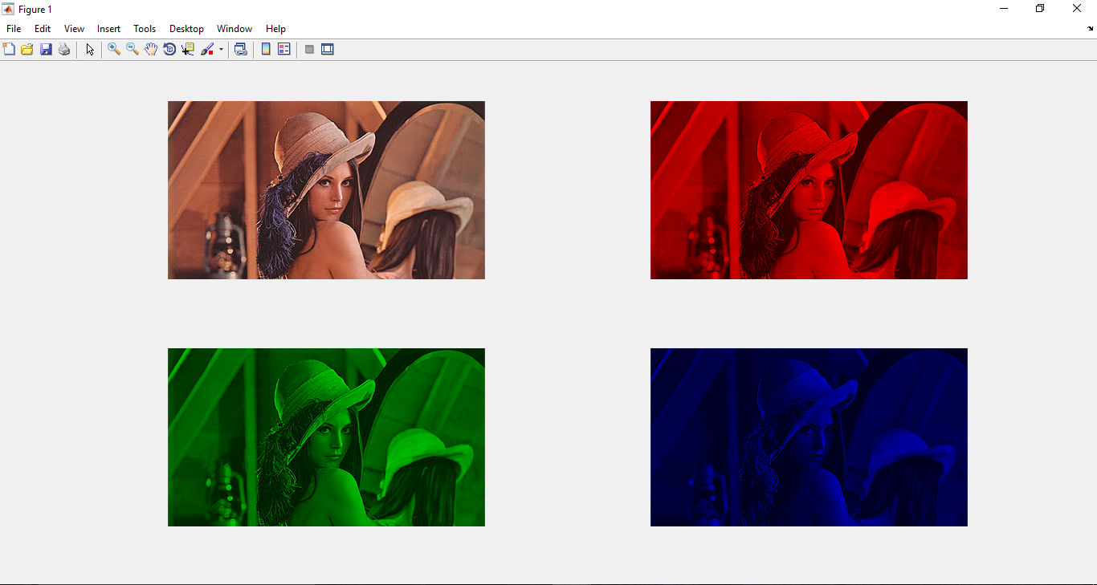

**MCQ:**

1. ______ is the main indicator of colour.

1. a) Hue
2. b) Saturation
3. c) Value
4. d) Intensity

2. If each element in the R,G and B component matrices are represented with 8-bit numbers, the total number of colours in the image is:

a) 28

b) 28+28+28

c) 28×28×28

d) 3×28

Answers: Q1 a) Hue, Q2) 2^8 * 2^8 * 2^8

Assignment – 2

clc;

clear all;

close all;

input = imread('len_top.jpg');

i=im2double(input);

s = rgb2hsv(input);

figure

subplot(311)

imhist(s(:,:,1)), title('Red')

subplot(312)

imhist(s(:,:,2)), title('Blue')

subplot(313)

imhist(s(:,:,3)), title('Green')

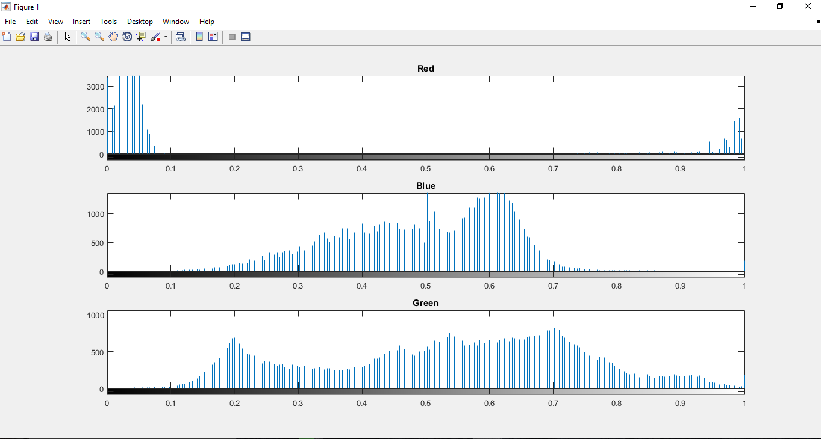

**MCQ:**

1. Full form of HSI format is

1. a) Hue Stain Intensity (b) High Saturation Intensity (c) Hue Saturation Intensity (d) High Saturation Index

2. HSV and HSI color format are same or not?

a) N0 b) YES

3. Which one of the following is not a color format?

a) YCbCr b) CMYK (c) YCbPr (d) CMYC

Answers: Q1 c) Hue Saturation Intensity, Q2 a) NO, Q3 d) CMYC

Assignment – 3

Q1

clc;

clear all;

close all;

input = imread('len_top.jpg');

s = rgb2hsv(input);

Inverted=1-s;

figure

imshow(s),title('Original HSV Image')

figure

imshow(Inverted),title('Inverted Image')

J = imadjust(s,[.2 .3 0; .6 .7 1],[]);

figure

subplot(311)

imhist(s(:,:,1)), title('Red')

subplot(312)

imhist(s(:,:,2)), title('Blue')

subplot(313)

imhist(s(:,:,3)), title('Green')

figure

imshow(J),title('Using Imadjust')

G = imgaussfilt(s);

figure

imshow(G),title('Gaussian Filter')

